1 Introduction 1
2 Scope and field of application 1
3 Definitions and Abbreviations 1
4 References 2
5 ASP.NET Core 3
6 EntityFramework Core 4
6.1 Introduction 4
6.2 Development Approaches 5
6.3 EF 6 vs EF Core 5
6.4 Database Provider 5
7 Json Web Token 6
7.1 Introduction 6
7.2 JWT Structure 7
7.2.1 HEADER 7
7.2.2 PAYLOAD 7
7.2.3 SIGNATURE 8
7.2.4 JWT In Microservices 9
8 SignalR Server 9
8.1 SingalR Hub 10
8.2 Database/Table Subscription 10
8.3 Service Register 10
9 MSMClientAPIService 10
9.1 Architecture 11
9.2 Generic Repository 11
9.3 User Repository and Auth Controller 11
9.4 Site Repository and Site Controller 12
9.5 Alarm Repository and Alarm Controller 13

DOCUMENT CHANGE RECORD

Rev. | Date | Author | Nature of revision
1.0 | 19.03.2018 | Ruby Pham | Initial Revision
1.1 | 10.04.2018 | Ruby Pham | Update classes diagram

Introduction
This document describes the ASP.NET Core Web API structure and new technologies to build the backend services for HTML5 .

Scope and field of application

Definitions and Abbreviations
MSM - Multisite Monitor
JWT - Json Web Token
JSON - Java Script Object Notation

References
- https://docs.microsoft.com/en-us/aspnet/core/
- https://docs.microsoft.com/en-us/ef/core/
- https://docs.microsoft.com/en-us/ef/core/providers/index
- https://medium.com/vandium-software/5-easy-steps-to-understanding-json-web-tokens-jwt-1164c0adfcec
- https://jwt.io/

ASP.NET Core
- ASP.NET Core is a cross-platform, high-performance, open-source framework for building modern, cloud-based, Internet-connected applications. With ASP.NET Core, you can:
- Build web apps and services, IoT apps, and mobile backends.
- Use your favorite development tools on Windows, macOS, and Linux.
- Deploy to the cloud or on-premises.
- Run on .NET Core or .NET Framework.
- Reference: https://docs.microsoft.com/en-us/aspnet/core/

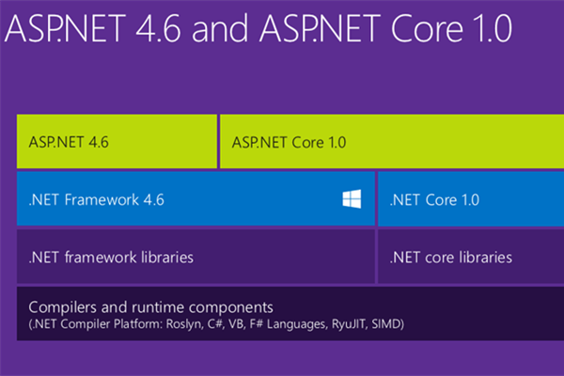
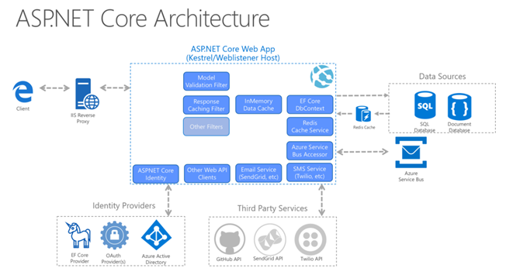

EntityFramework Core

Introduction
- Entity Framework (EF) Core is a lightweight, extensible, and cross-platform version of the popular Entity Framework data access technology.
- EF Core is an object-relational mapper (O/RM) that enables .NET developers to work with a database using .NET objects. It eliminates the need for most of the data-access code that developers usually need to write. EF Core supports many database engines, using Database Providers
- Reference: https://docs.microsoft.com/en-us/ef/core/

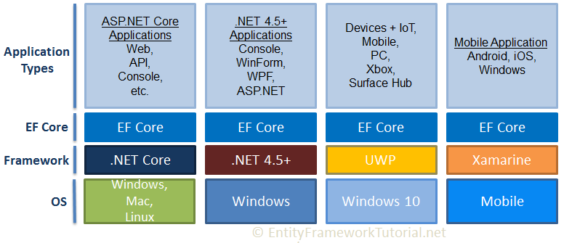

Development Approaches
EF Core supports two development approaches 1) Code-First 2) Database-First. EF Core mainly targets the code-first approach to support many database engines, and provides little support for the database-first approach because the visual designer or wizard for DB model is not supported as of EF Core 2.0.

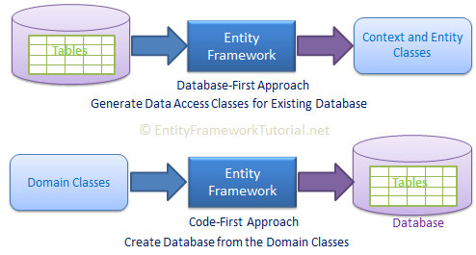

EF 6 vs EF Core
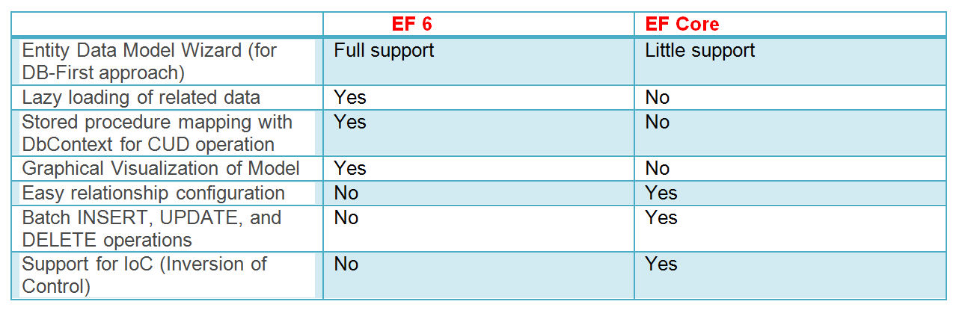

Database Provider
- Entity Framework Core uses a provider model to access many different databases. EF Core includes providers as NuGet packages which you need to install.
- https://docs.microsoft.com/en-us/ef/core/providers/index

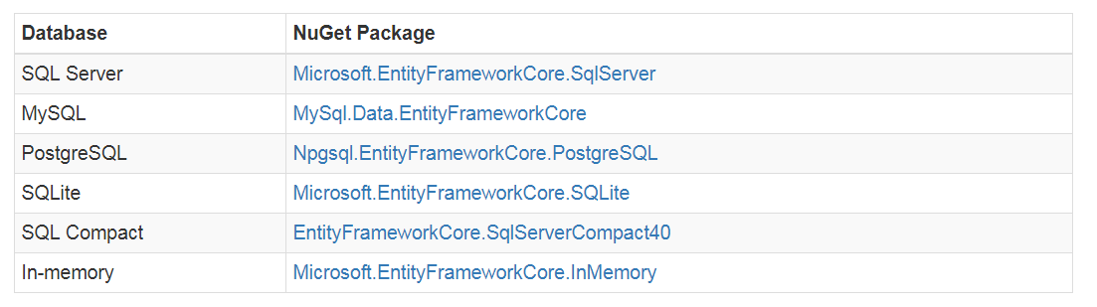

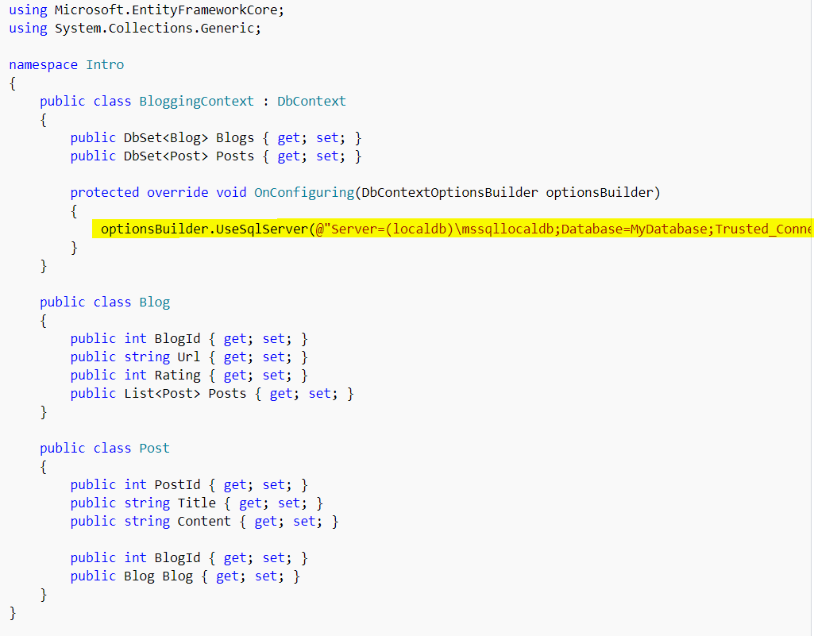

Json Web Token

Introduction
JSON Web Token (JWT) is a compact URL-safe means of representing claims to be transferred between two parties. The claims in a JWT are encoded as a JSON object that is digitally signed using JSON Web Signature (JWS).
Simply put, a JWT is just a string with the following format:

It should be noted that a double quoted string is actually considered a valid JSON object.
To show how and why JWT are actually used, we will use a simple 3 entity example (see the below diagram). The entities in this example are the user, the application server, and the authentication server. The authentication server will provide the JWT to the user. With the JWT, the user can then safely communicate with the application.

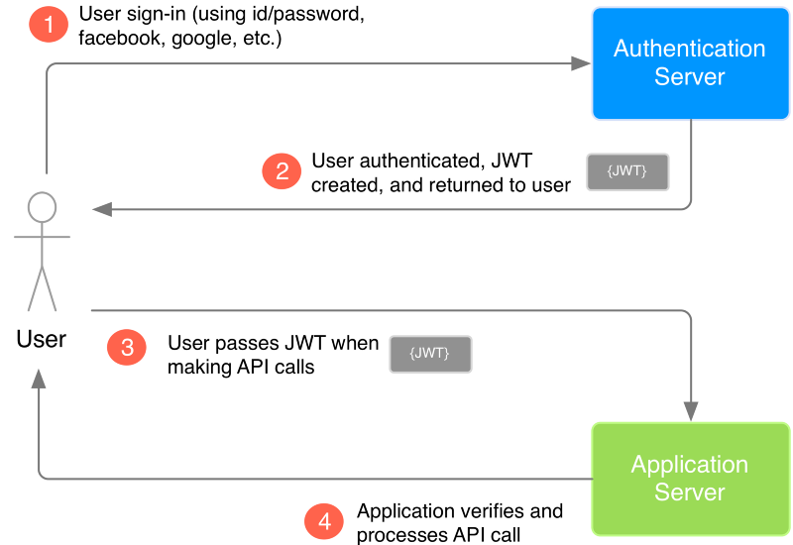

JWT Structure

HEADER

The header component of the JWT contains information about how the JWT signature should be computed. The header is a JSON object in the following format:
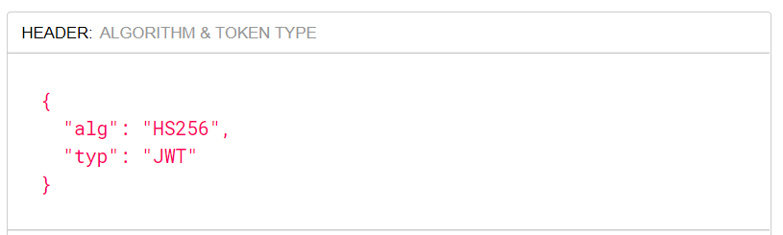

In this JSON, the value of the “typ” key specifies that the object is a JWT, and the value of the “alg” key specifies which hashing algorithm is being used to create the JWT signature component. In our example, we’re using the HMAC-SHA256 algorithm, a hashing algorithm that uses a secret key, to compute the signature

PAYLOAD

The payload component of the JWT is the data that‘s stored inside the JWT (this data is also referred to as the “claims” of the JWT).

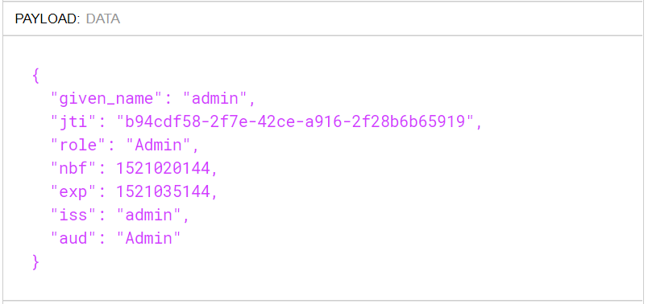

SIGNATURE

The signature is computed using the following pseudo code:
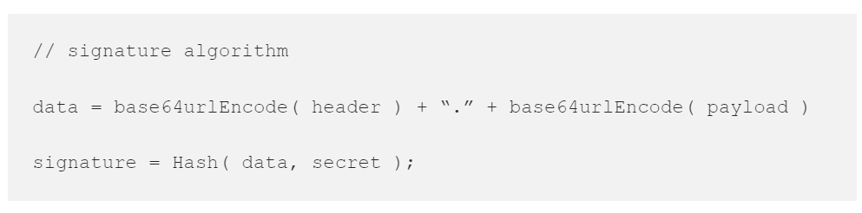

In our example, both the header, and the payload are base64url encoded as:

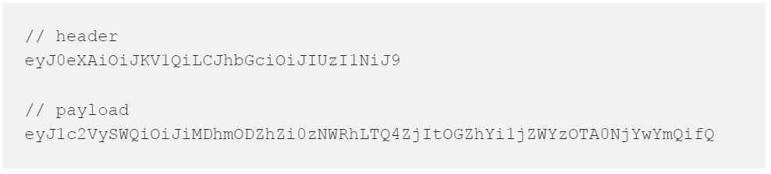

Then, using the joined encoded header and payload, and applying the specified signature algorithm(HS256) on the data string with the secret key set as the string “secret”, we get the following JWT Signature:
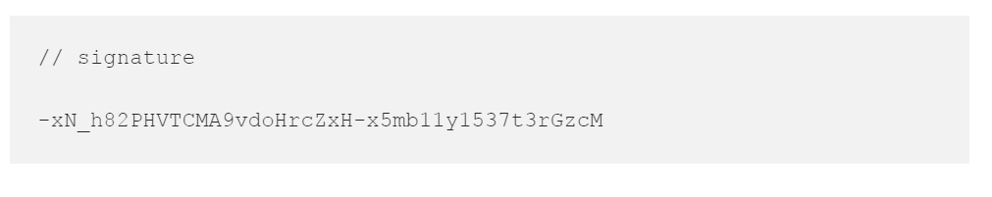

JWT In Microservices
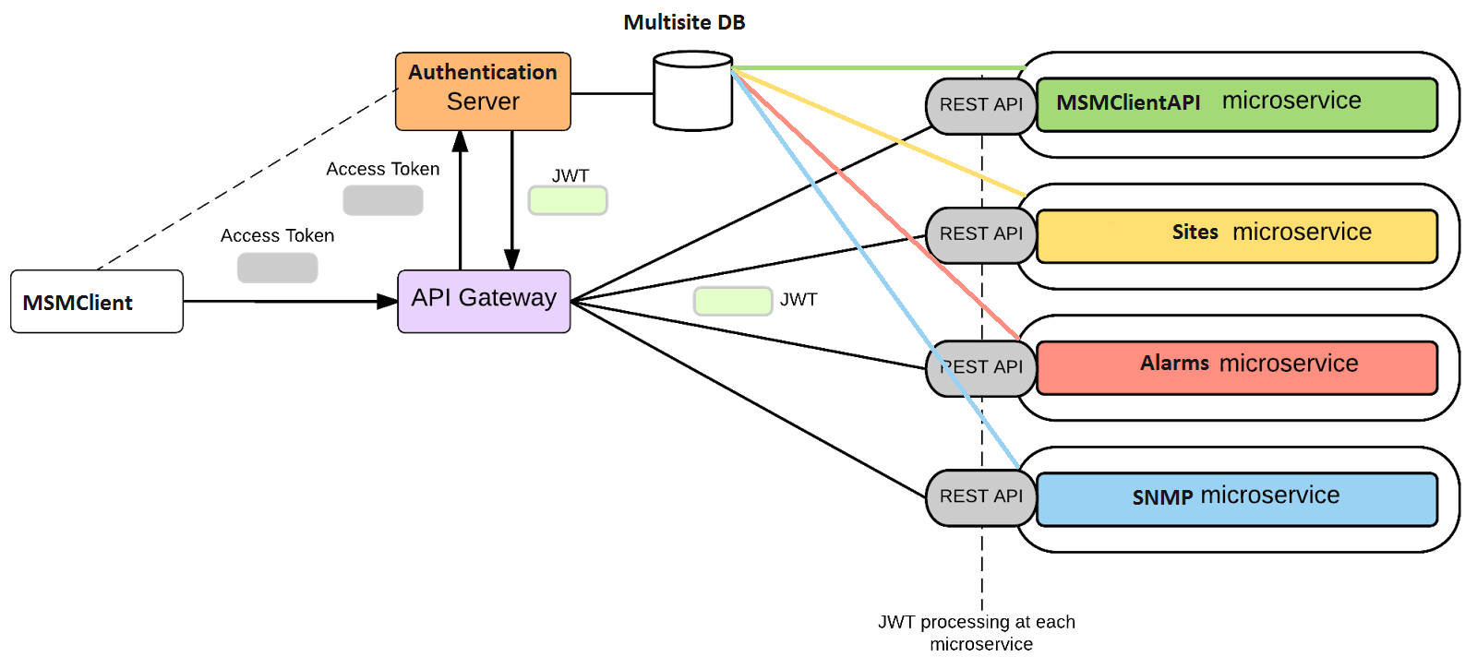

SignalR Server
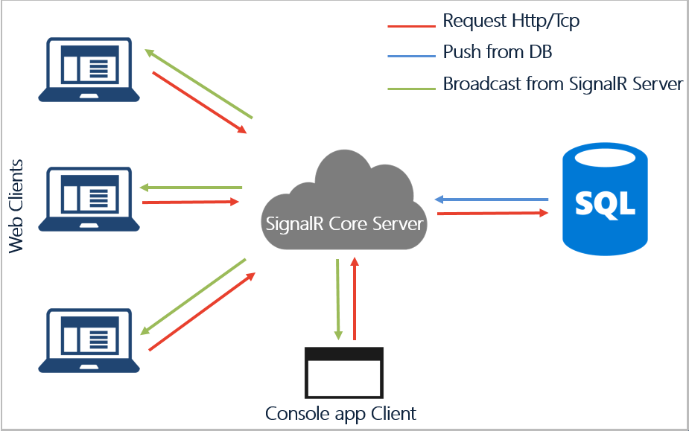

These package need to be installed for SingalR on server side:

Install-Package Microsoft.AspNetCore.SignalR -Version 1.0.0-preview2-final
Install-Package SqlTableDependency -Version 6.1.0

SingalR Hub
Here is the AlarmHub example to invoke a corresponding task.

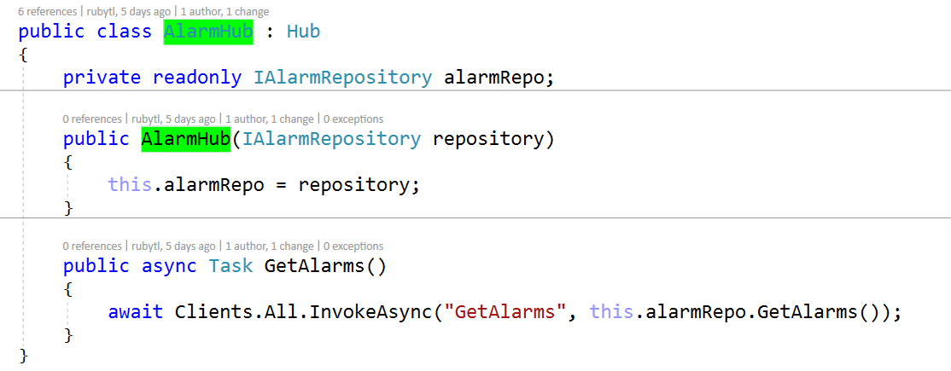

Database/Table Subscription

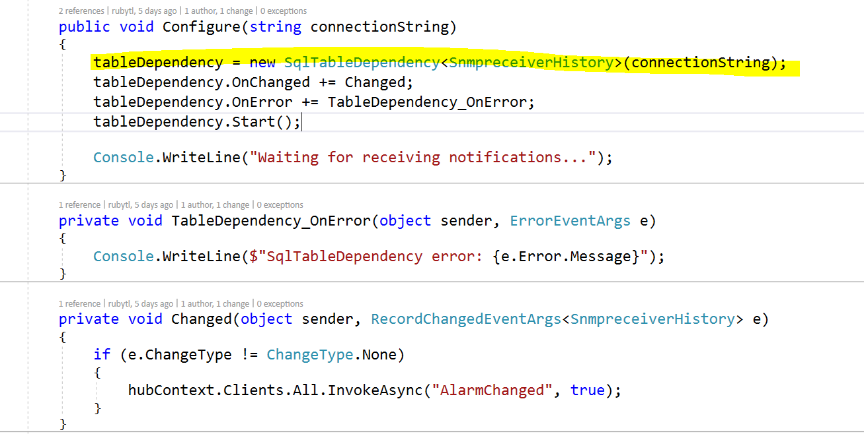

Service Register



MSMClientAPIService

Architecture
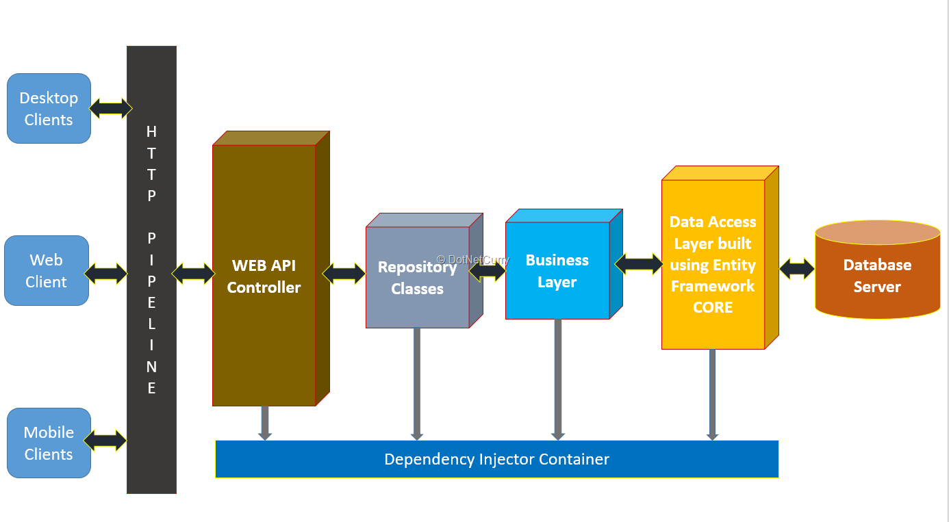

Generic Repository
The EntityBaseReposity is the base class to manage CRUD operations and any other possible operations related to to db.
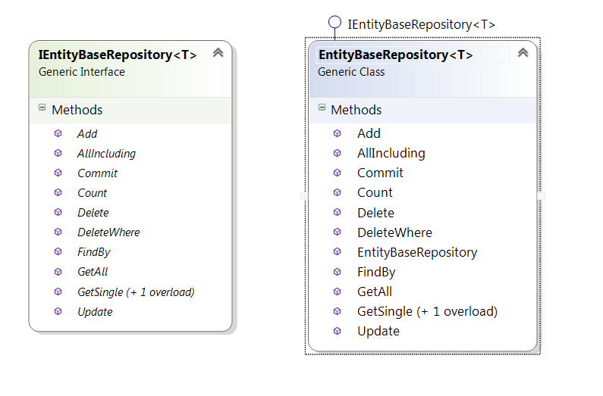

User Repository and Auth Controller

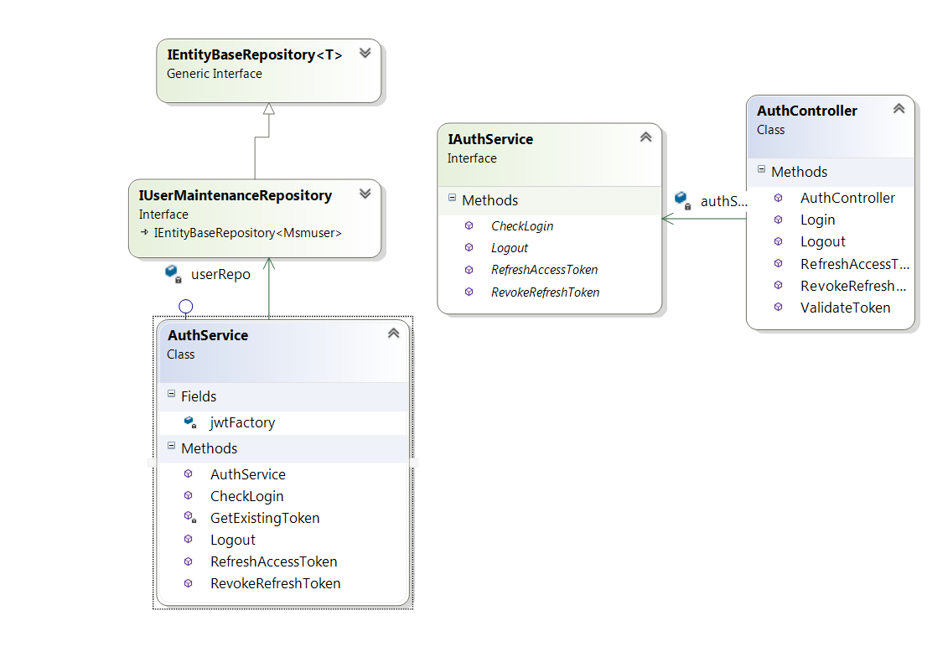

Site Repository and Site Controller
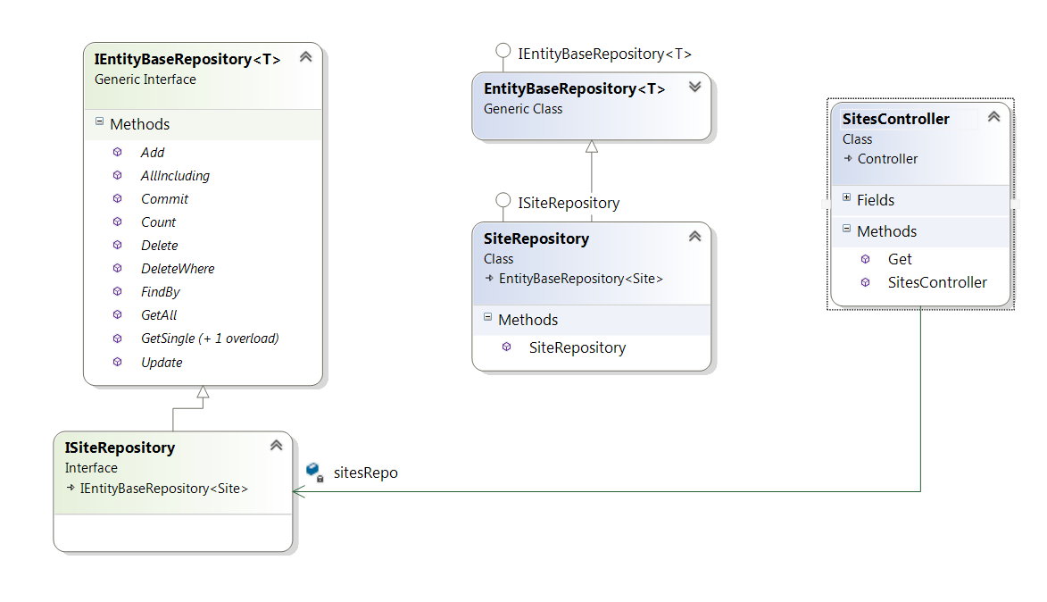

Alarm Repository and Alarm Controller
